**Code with Annotations**

DIGITAL SOLUTIONS IA2 ⏐ CAITLIN PETT ⏐ 2024 ⏐ YEAR 12

**Introduction**

This Document images of the code written to create the QPC website. Python, HTML, CSS, and SQL languages were used to create the page, and it was written on the code editor Visual Studio Code.

1. **Code Layout in VS Code**

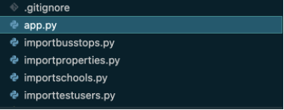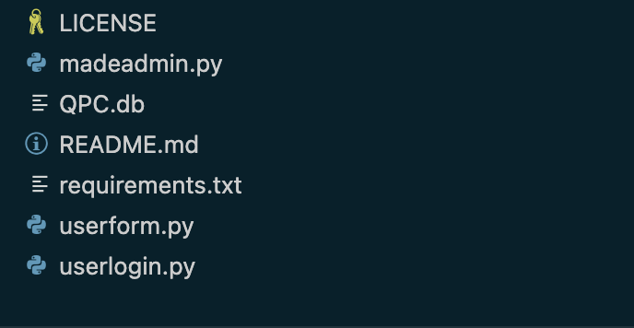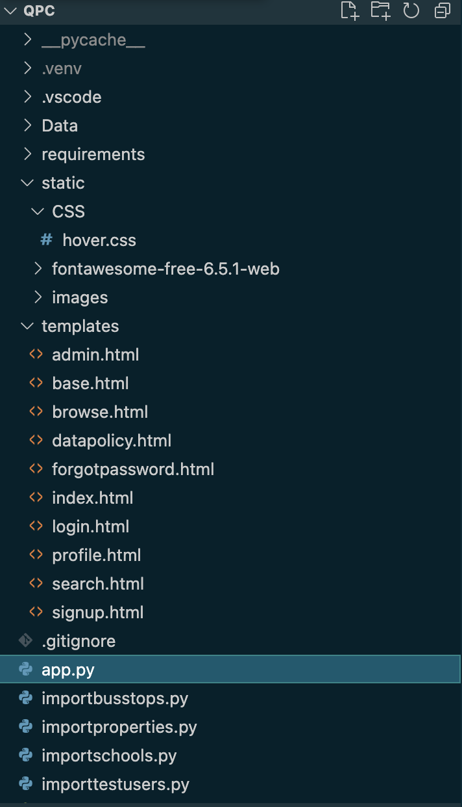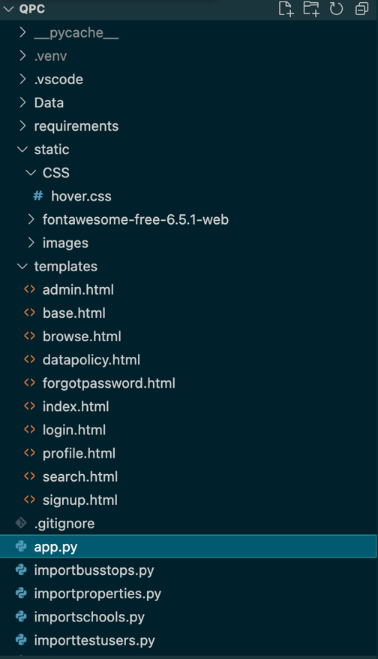

1. **Application File**

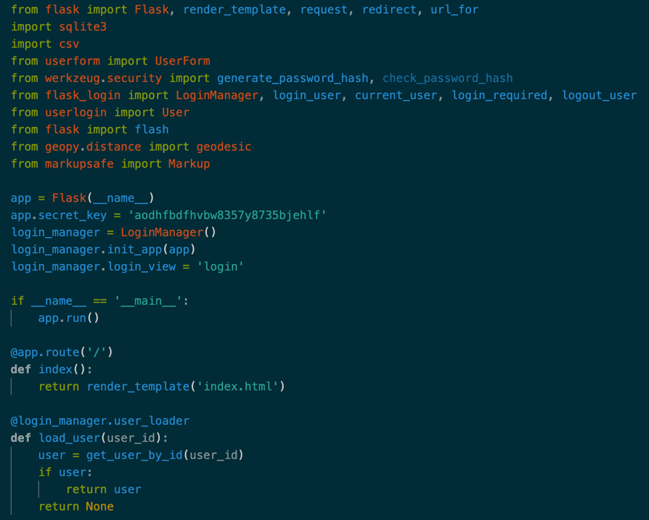App.py contains the server-side python code that does not create any physical elements to the website, but instead listens to the http requests from the web pages. The code uses the Python Flask framework to setup routes for each request the website can do (coded elements). The routes process the requests such as a GET and POST by performing the business logic such as validation and storing the data in the database.

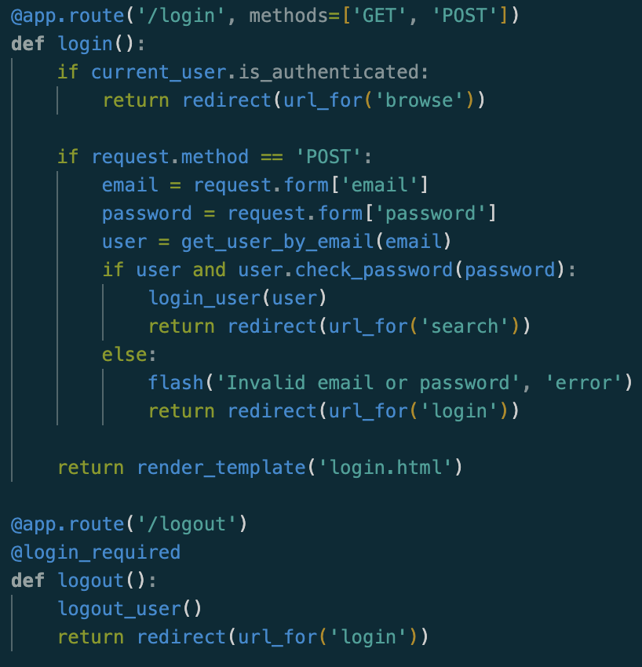

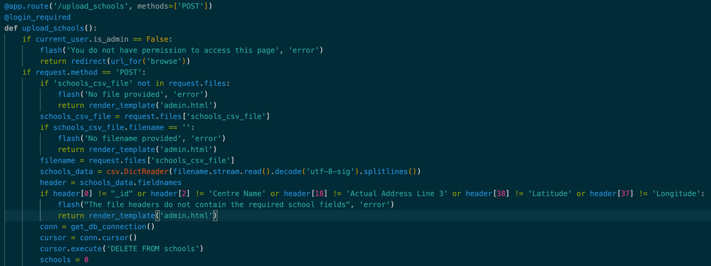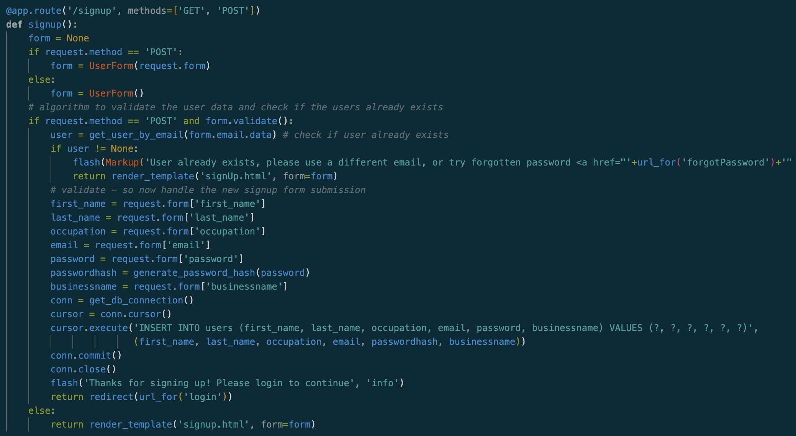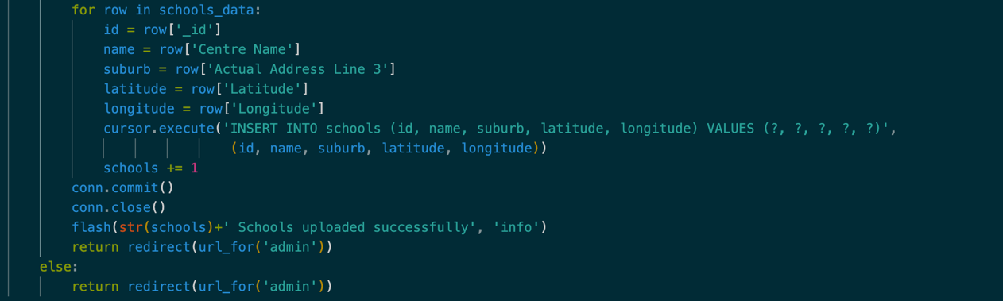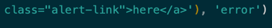

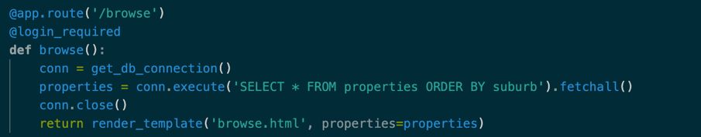Almost the same route was created for /upload_bus_stops with the only differences being in the headers, which are slightly different to the schools data, but it uses the same code and for that reason was omitted from these screenshots.

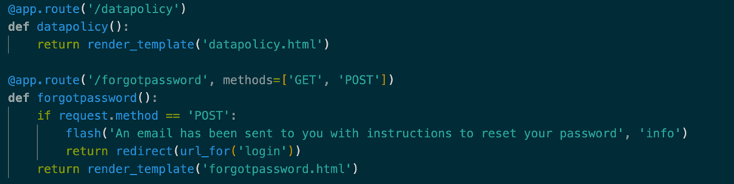

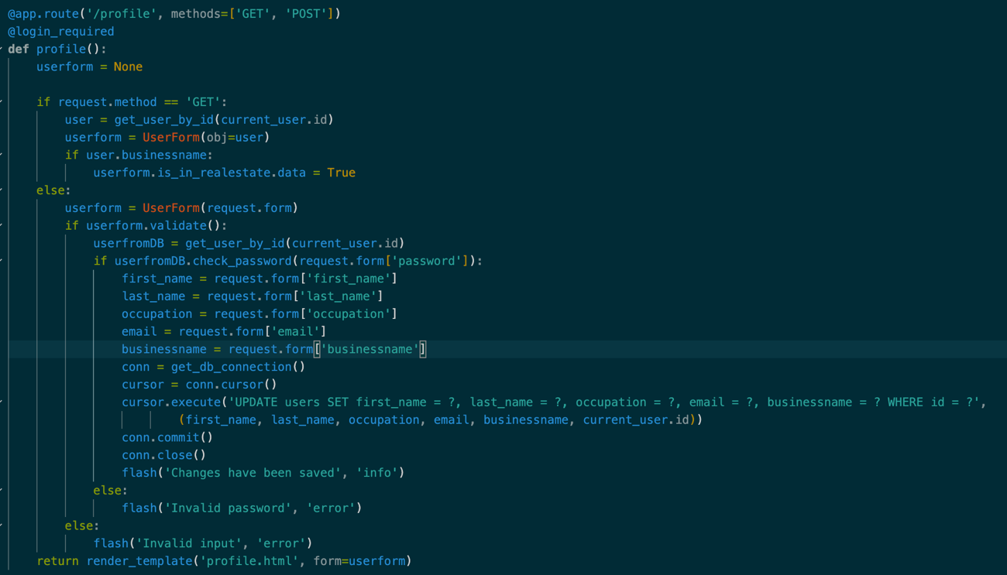

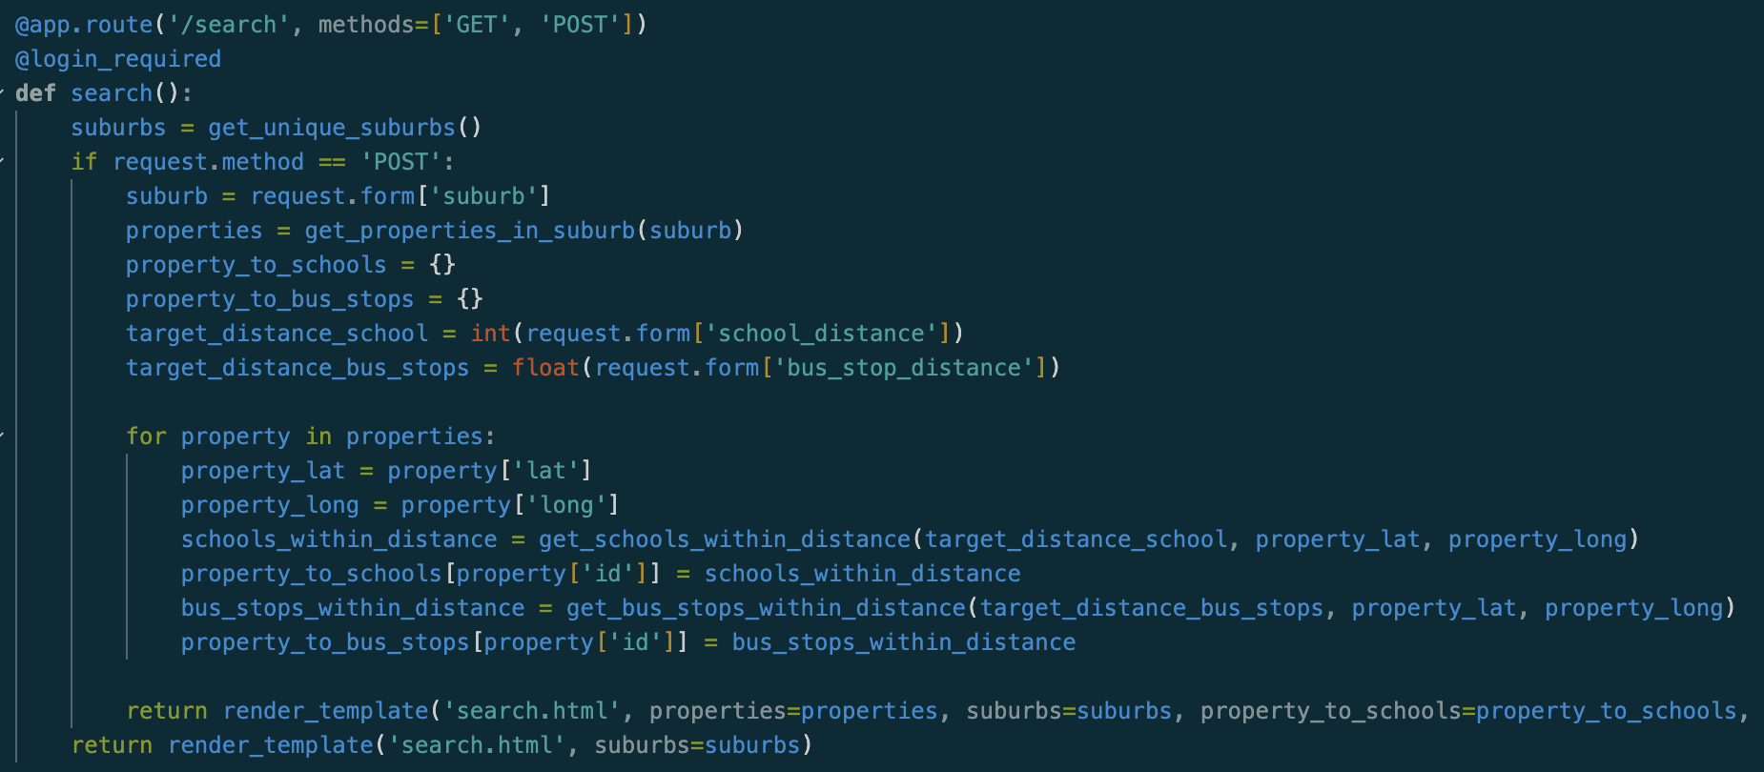

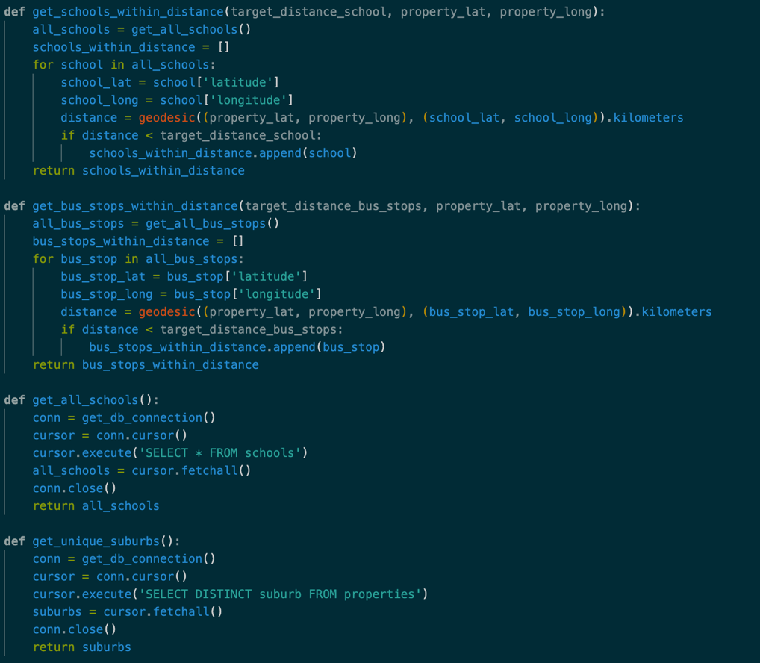

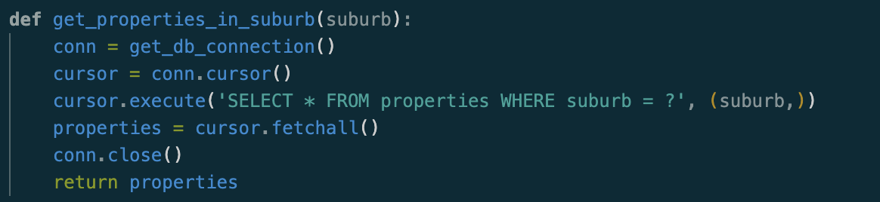

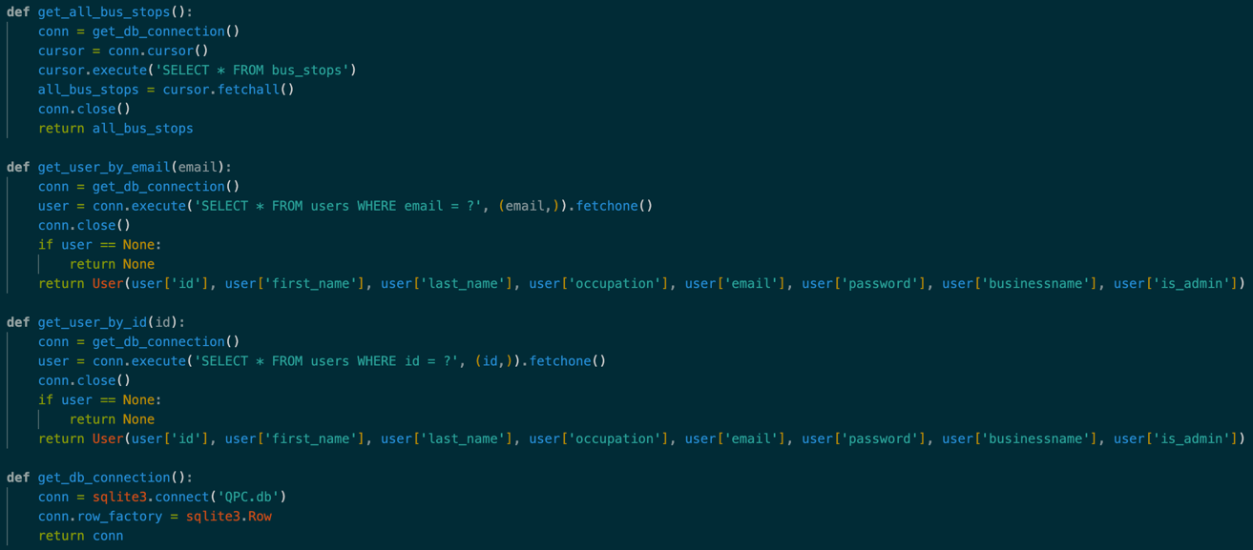

1. **Importing Data Files**

These files use python to create the tables in the QPC database, and add data when relevant, each file represents the creation of a new table. Only two files have been shown. Firstly importbus_stops.py, which takes the data given in the technical proposal, creates a bus_stop table, and inserts the data into there. The same logic is used with the importschools.py file, except it creates the schools table and inserts the schools data.

1. bus_stops table: importbusstops.py. Code annotations are in grey within the screenshot for this file.

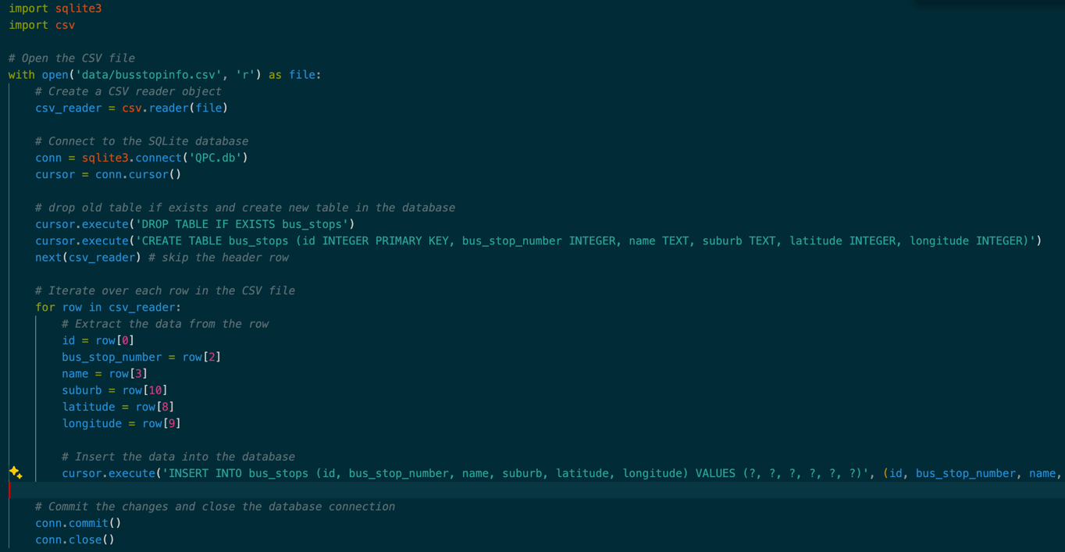

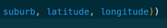

1. properties table: importproperties.py. The same logic is used to create the properties.

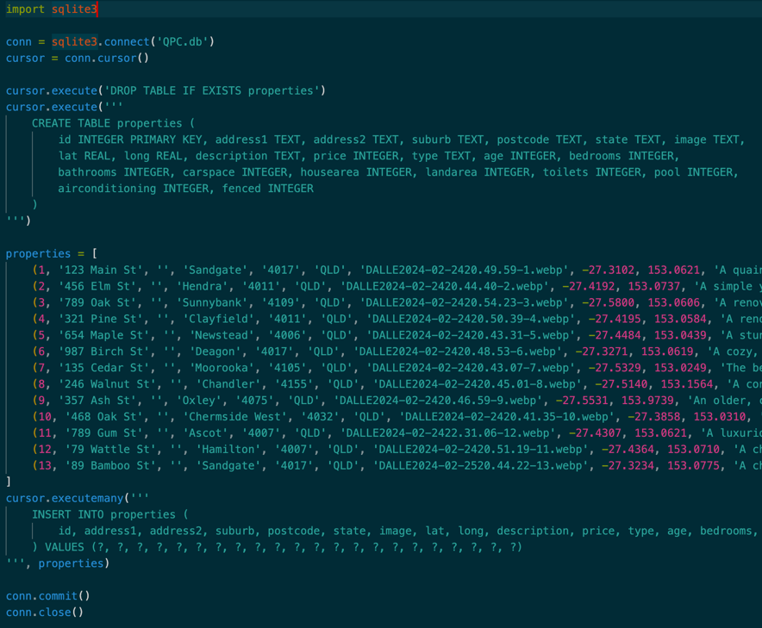A small differences is that this file inserts data written within the file into the table, shown here. All the data did not fit within the screenshot, but it simply extends further to the left, inserting the required data.

All the data is fictional created by ___ and is not relevant to this document.

REST OF DATA

1. 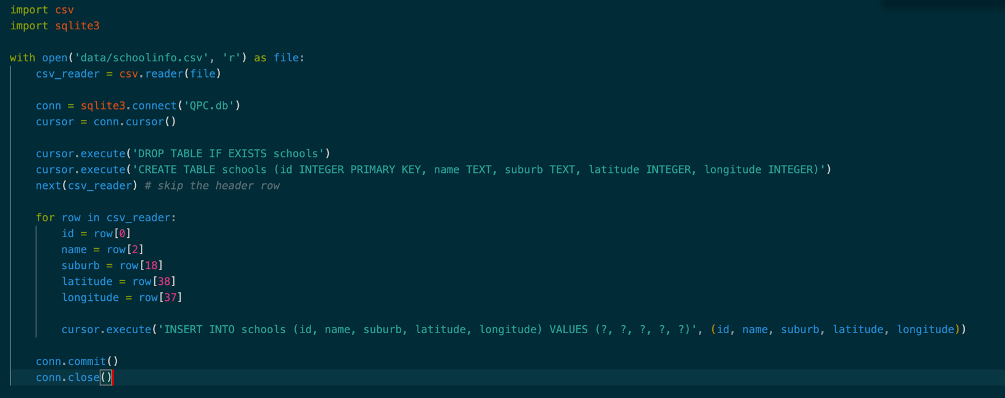users table: importusers.py
2. Other Python Files
3. 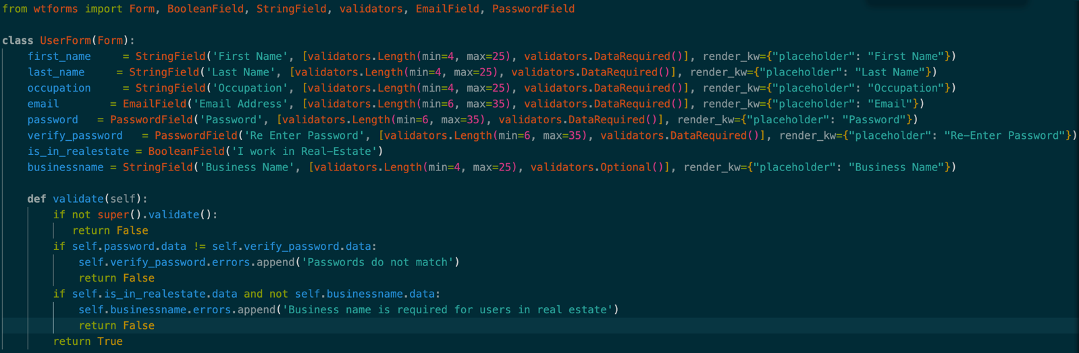userform.py
4. userlogin.py

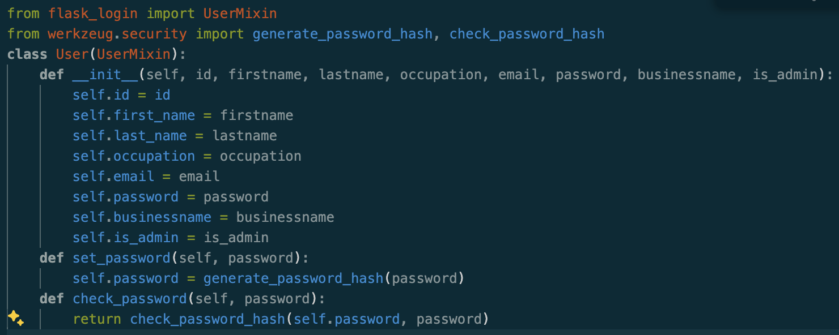

1. madeadmin.py

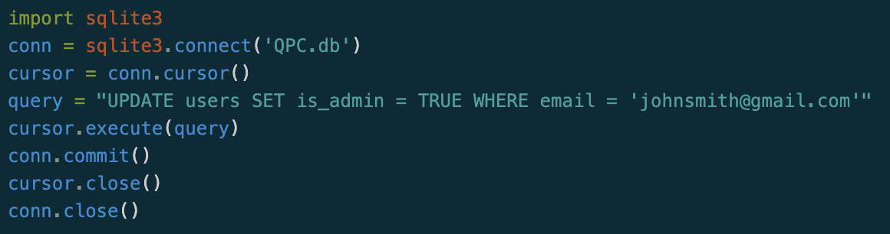

1. Templates – html files
2. base.html

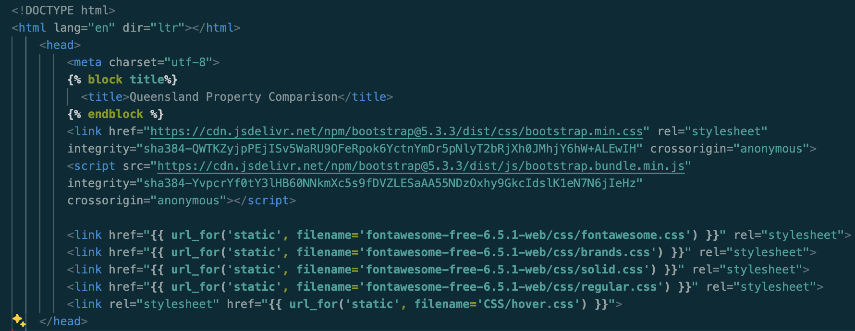

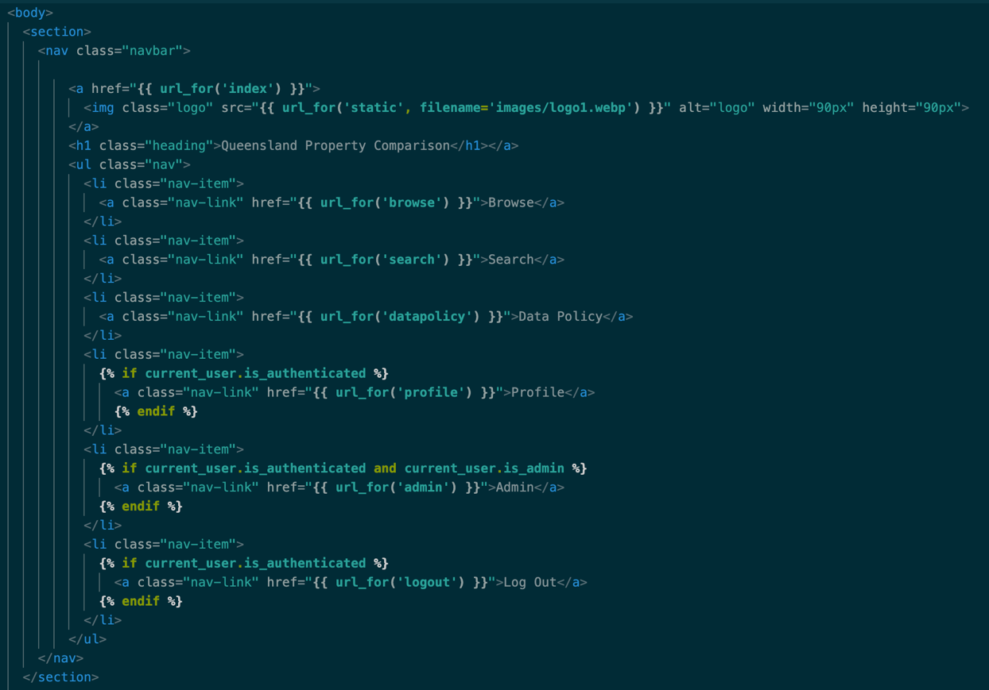

1. 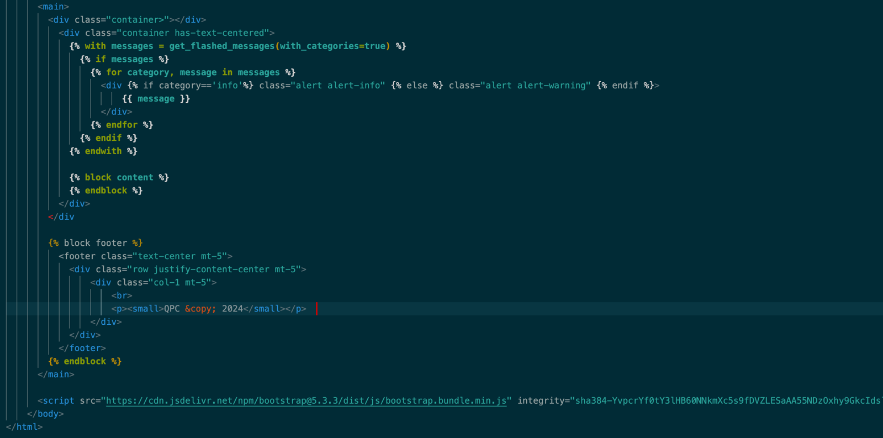admin.html

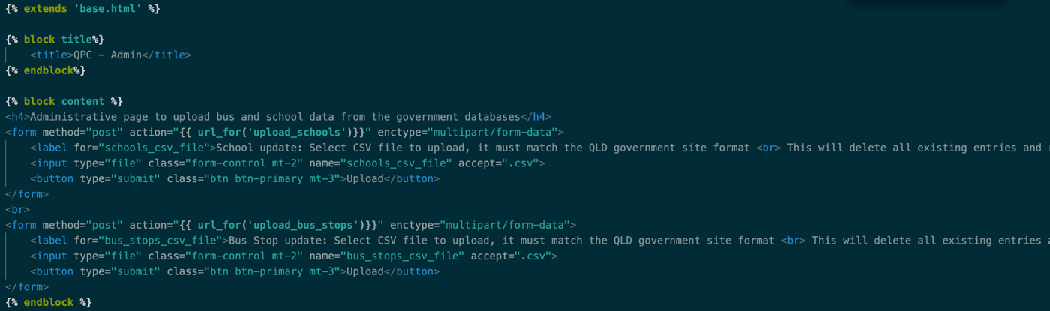





1. browse.html

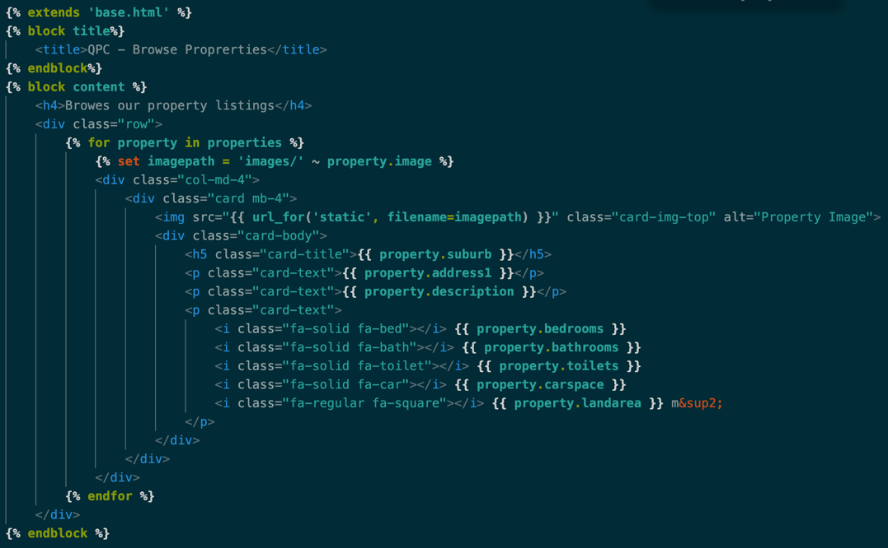

1. datapolicy.html

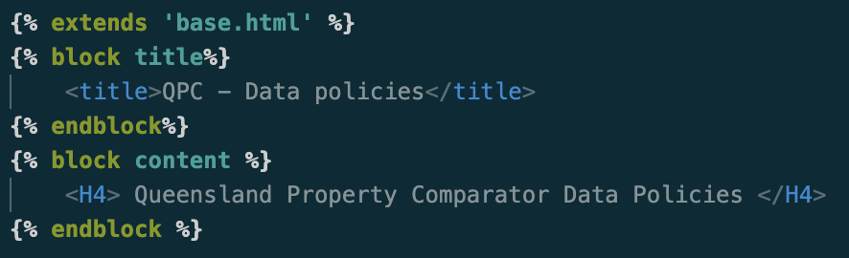

1. forgotpassword.html

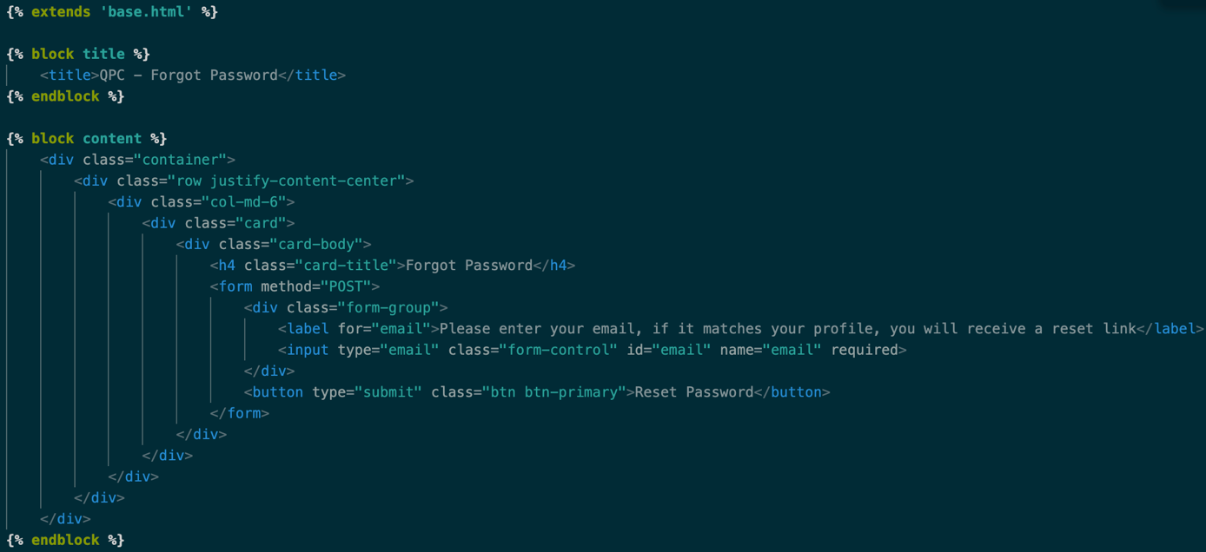

1. 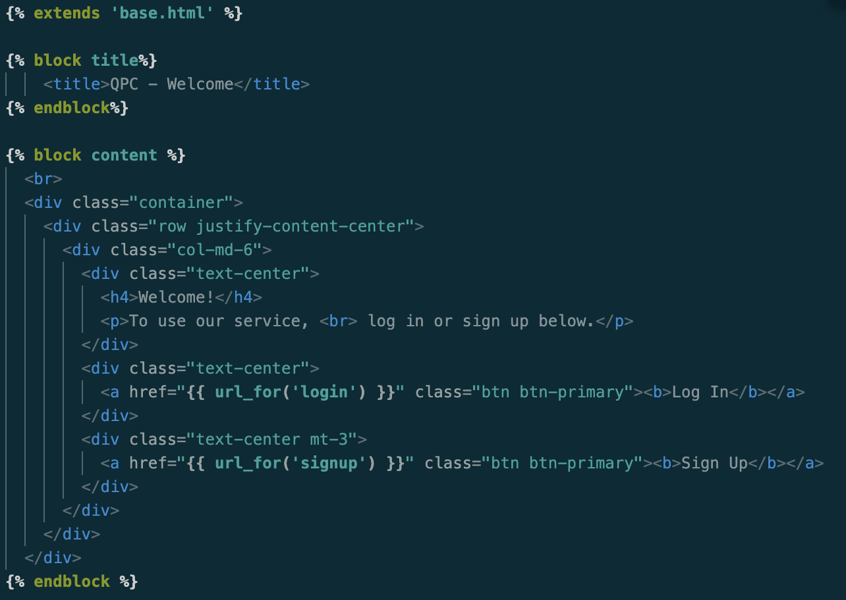index.html
2. login.html

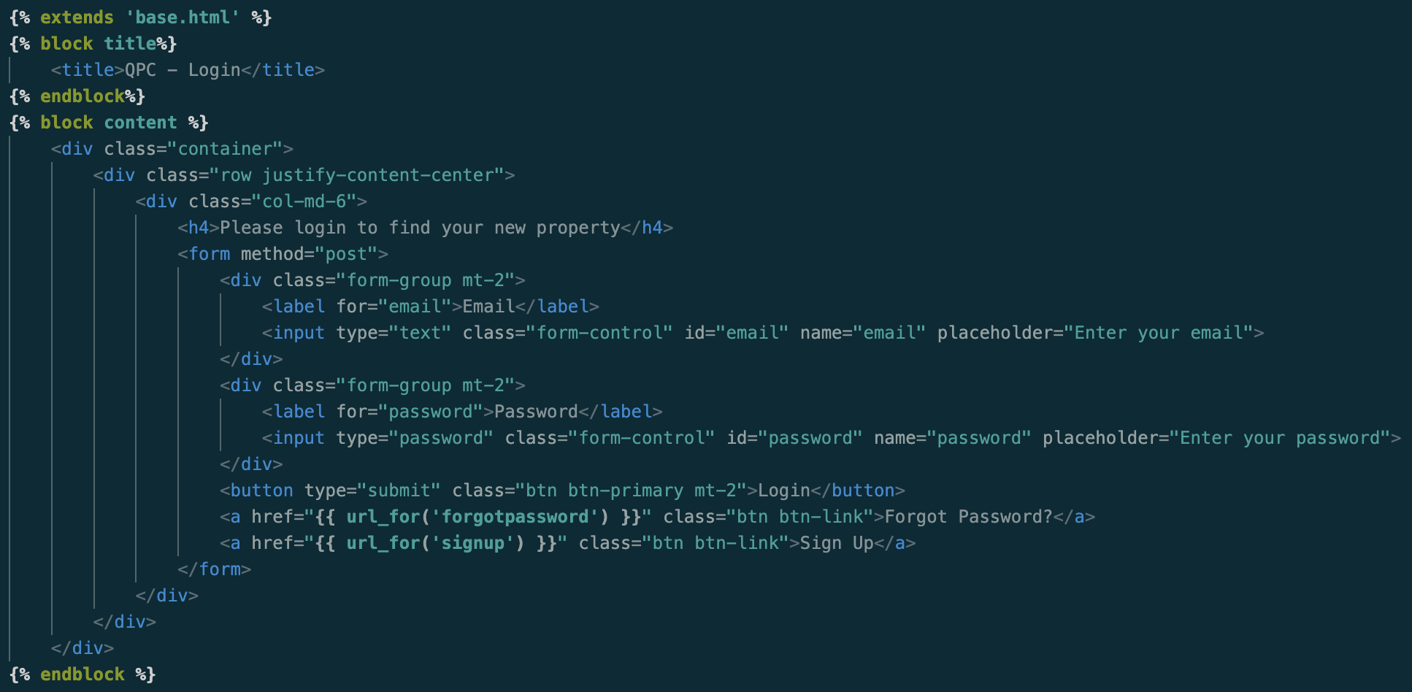

1. 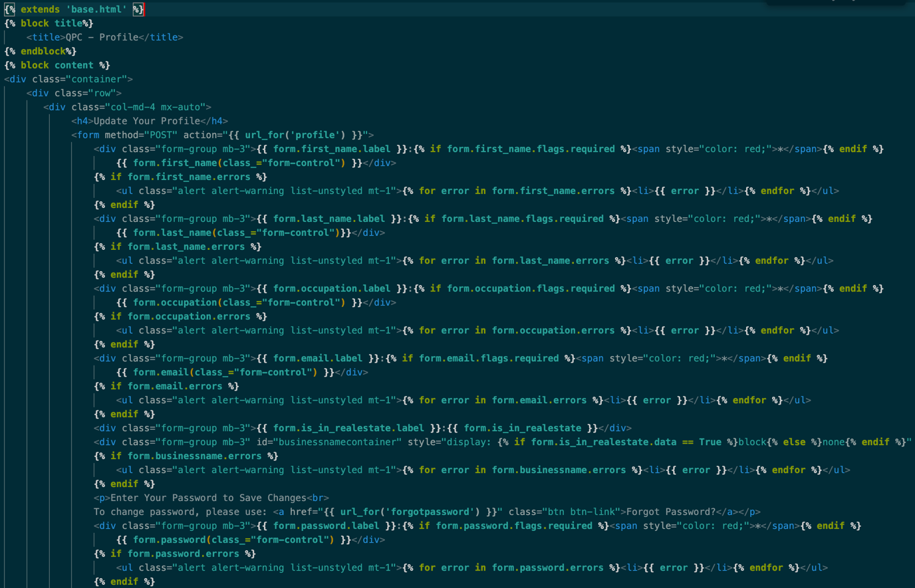profile.html

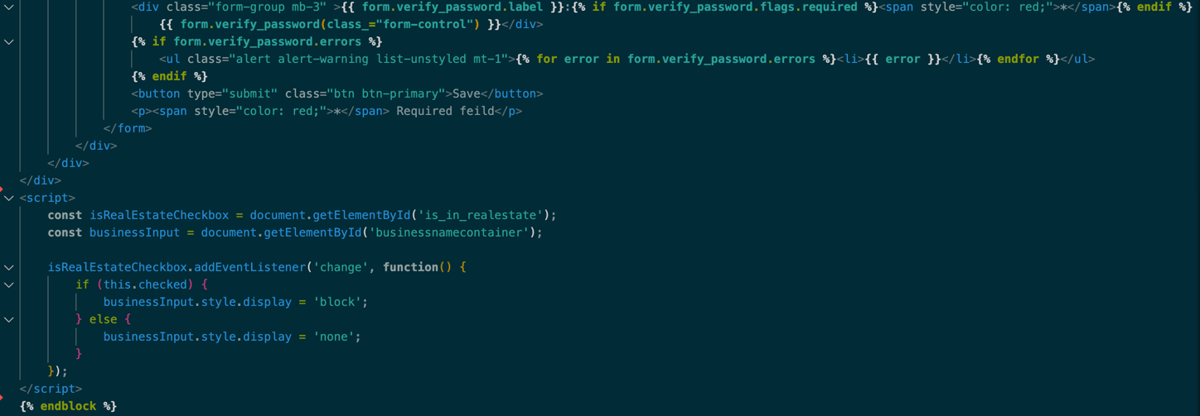

1. search.html

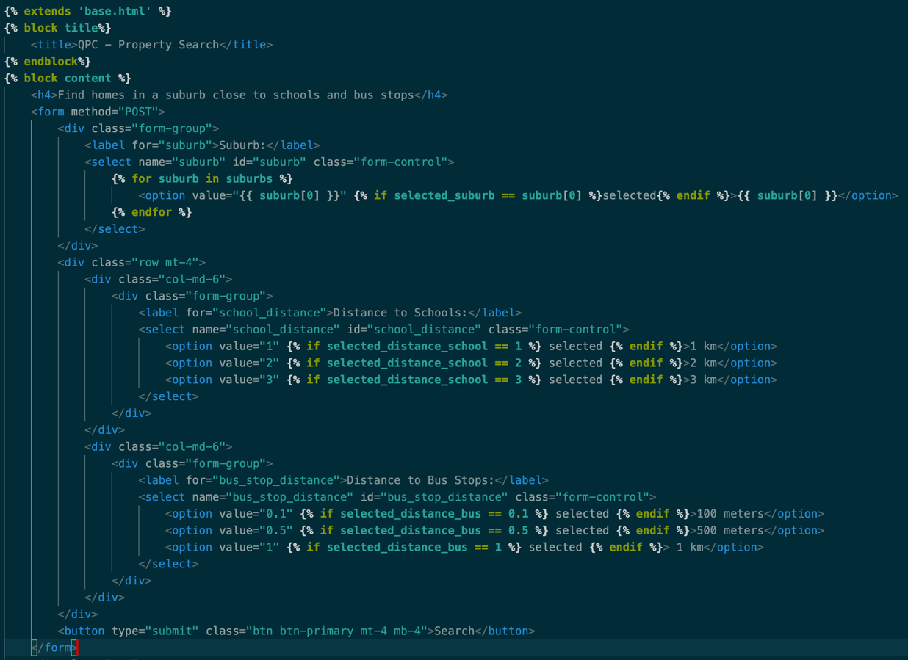

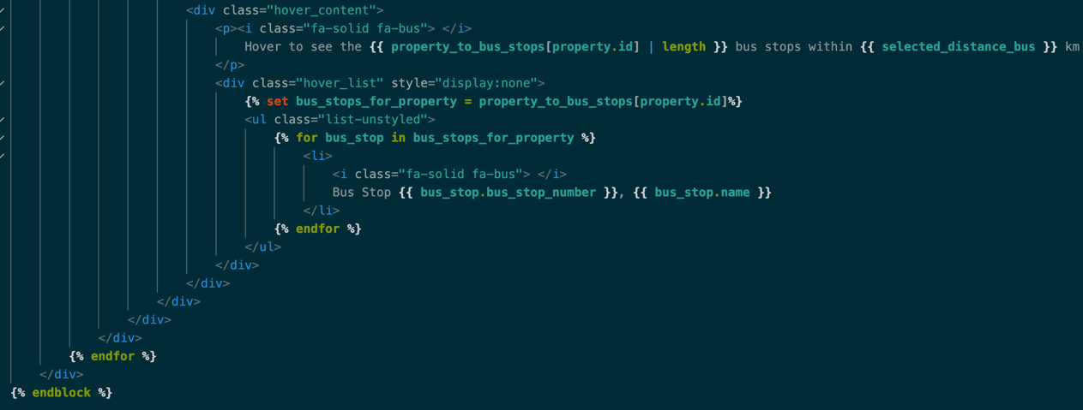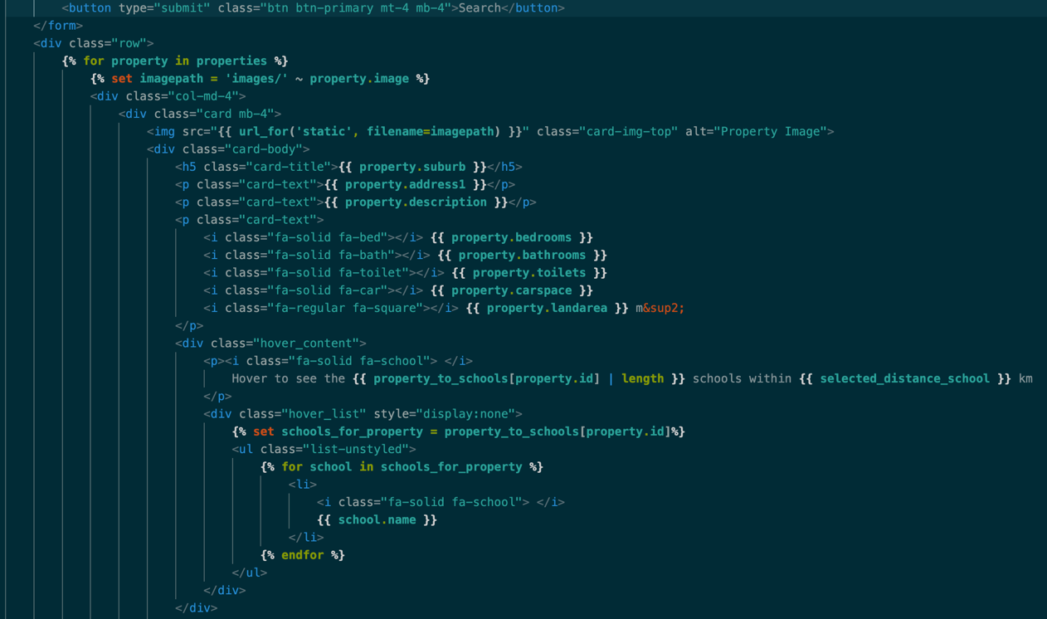

1. 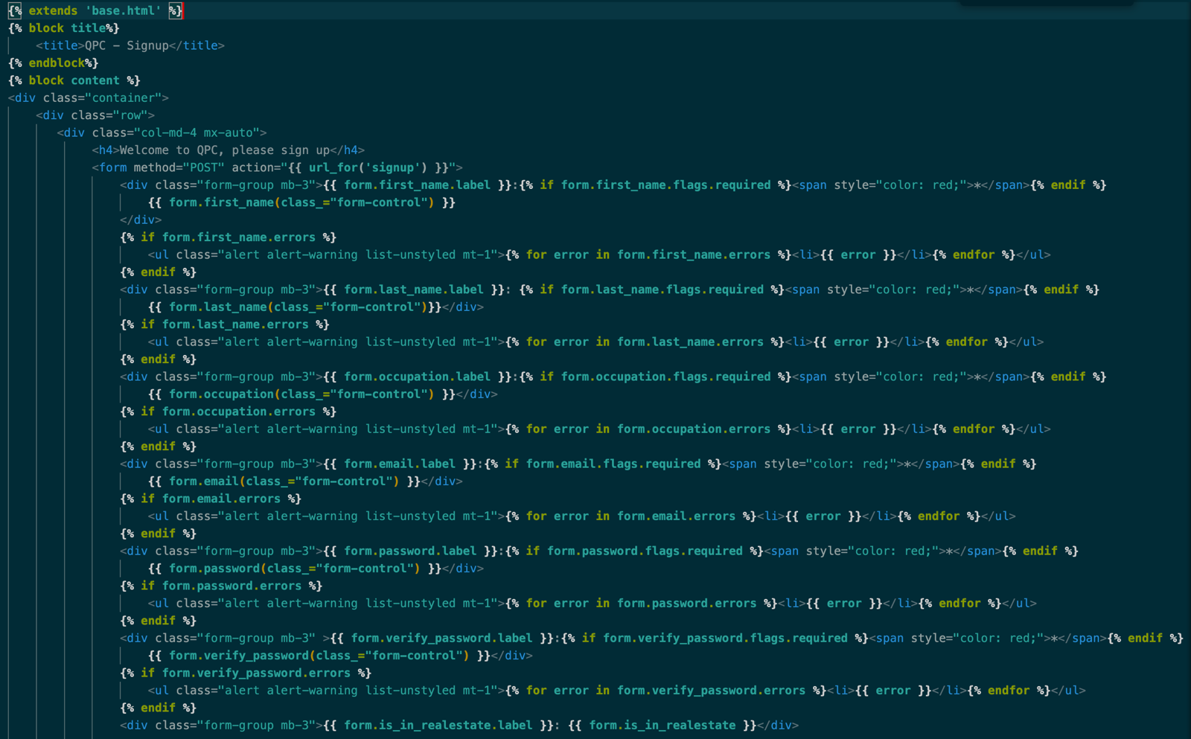signup.html

